Gender-Based Electric Vehicle (EV) Market Analysis in India

# Name: -Tabish Anwar

Dataset link: -https://drive.google.com/file/d/191duwilKgMn0GGxVLMenTkW7OdtdvT_e/view?usp=sharing

Github link: -

https://github.com/Tabish247/Market-Analysis-of-ev-market-based-on-gender.git

# Introduction

This report adds a gender-focused perspective to the EV market analysis in India. While the original study did not consider gender as a factor, incorporating it can provide valuable insights into preferences, adoption behavior, and marketing strategies.

# 1. Gender Segmentation & Market Distribution

Understanding the gender-based distribution of EV adoption is essential to tailor product offerings, marketing strategies, and infrastructure. The chart below presents the estimated distribution across genders in India’s EV market.

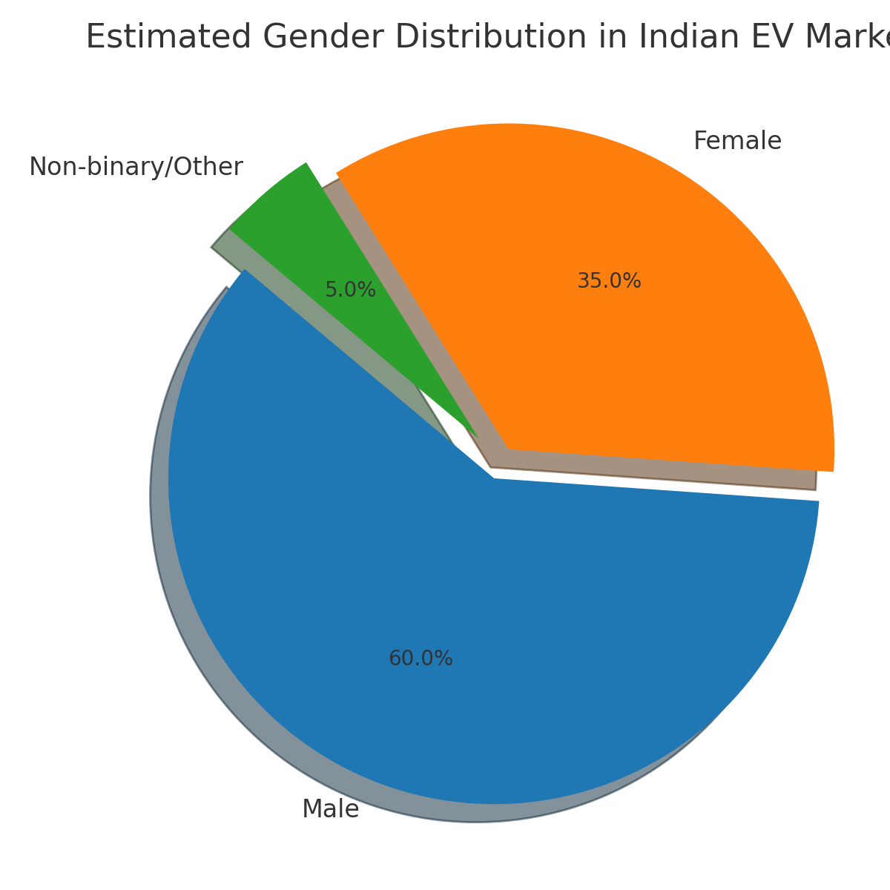

Figure 1: Estimated Gender Distribution in the EV Market.

Although males currently dominate EV purchases, female and non-binary segments are emerging with distinct priorities.

## 2. Gender-Relevant Augmentation

|  |  |  |  |
| --- | --- | --- | --- |
| Variable | Male Preference | Female Preference | Non-Binary/Other Preference |
| Charging Stations | Fast-charging, road trips | Accessible & safe locations | Home/workplace & inclusive design |
| Market Share | Tech brands, high sales zones | Trusted brands, peer reviews | Ethical & inclusive brands |
| Annual Sales | Performance-driven adoption | Comfort, price-focused | Feature- and brand-values focused |
| EV Type | Sporty scooters, sedans | Compact, city-friendly EVs | Design-led, connected vehicles |

# 3. Feature Preferences by Gender

Preferences across EV features differ significantly among genders. The following bar chart visualizes how each gender scores key features.

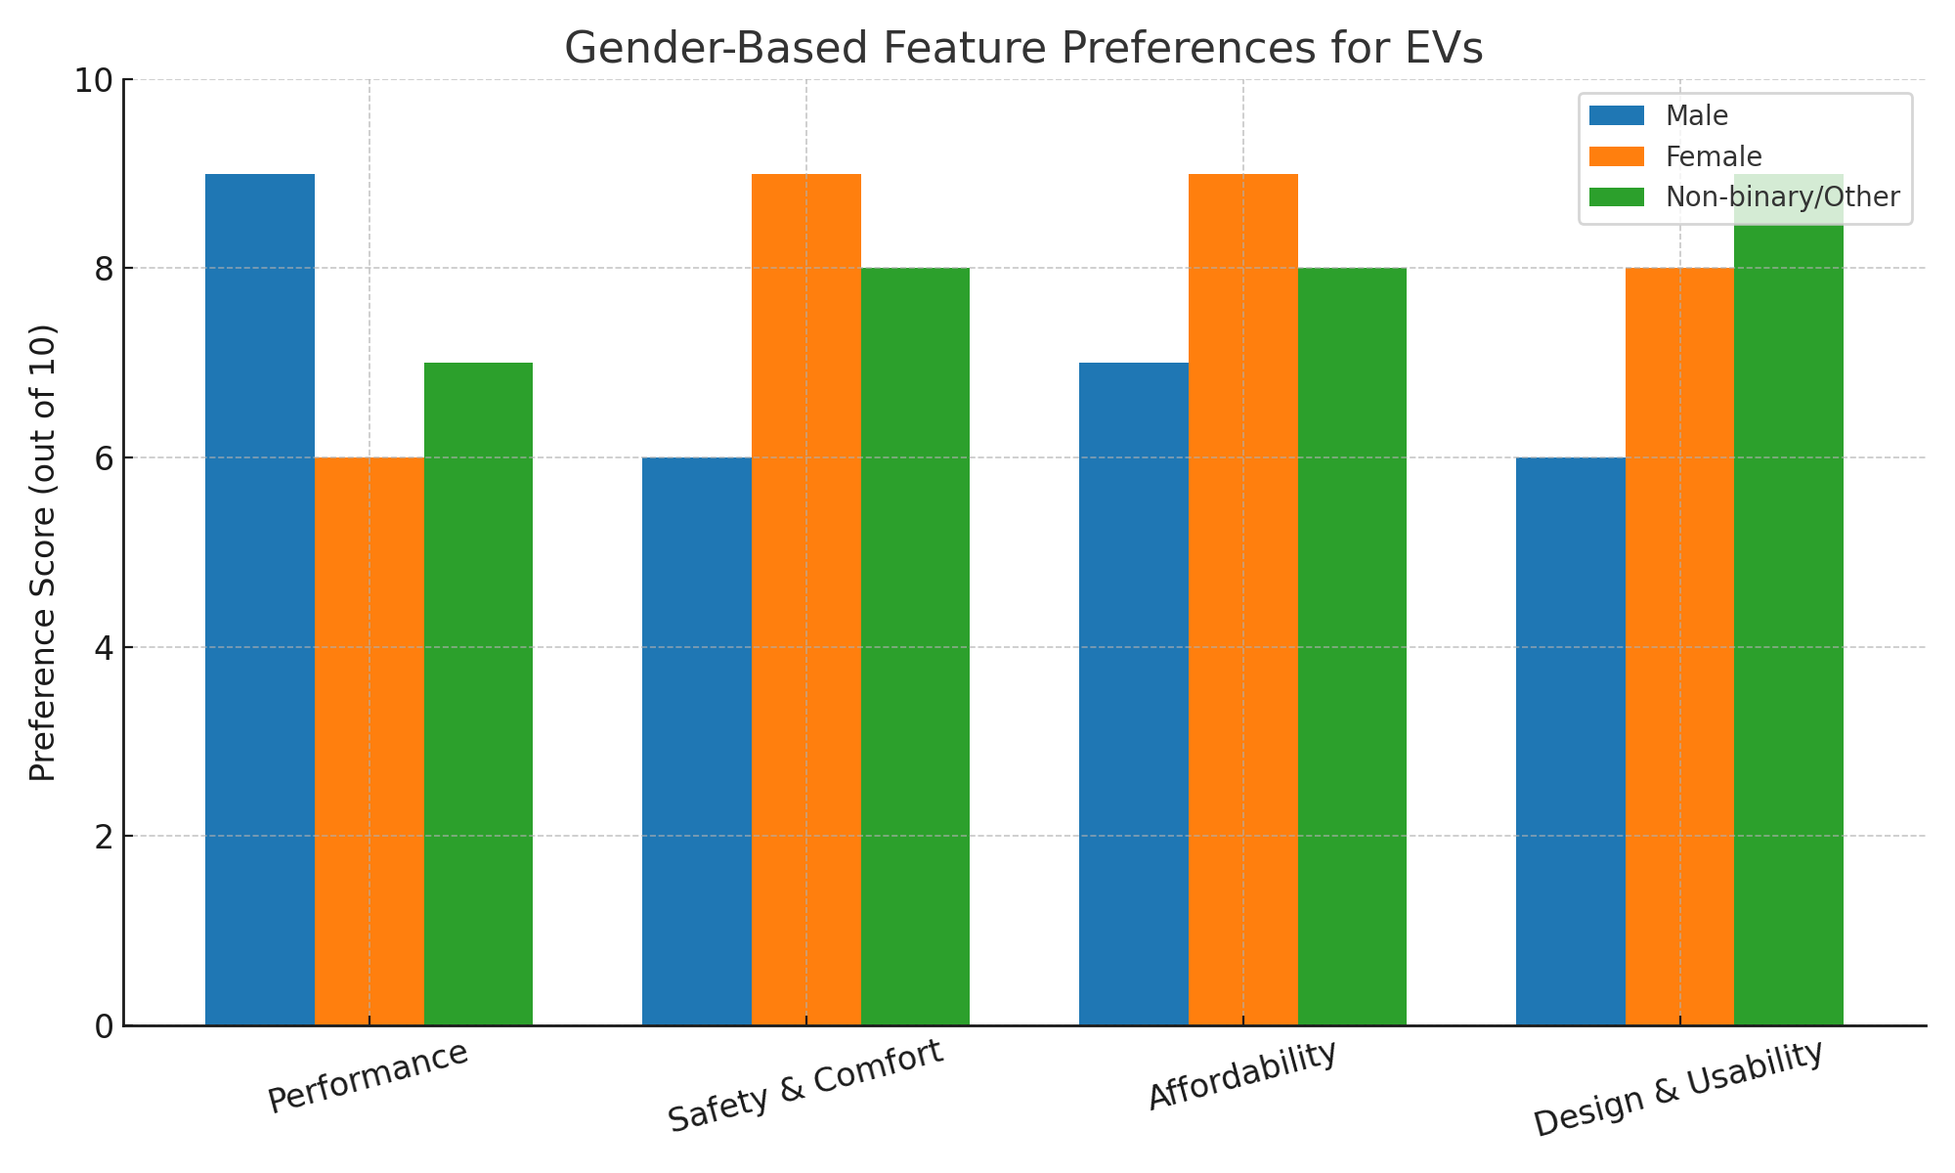

Figure 2: Feature Preferences for EVs by Gender.

- Males prioritize performance and brand presence.  
- Females rate affordability, safety, and usability as top concerns.  
- Non-binary users are strongly driven by inclusive design and eco-brand ethics.

# 4. Market Cluster Mapping with Gender Context

States from the original analysis can be enriched by gender variables to identify opportunities:  
• High-Adoption, Male-Dominant (e.g., Maharashtra, Karnataka)  
• High-Growth, Female-Adoption Potential (e.g., Gujarat, Telangana)  
• Low-Adoption, Long-Term Non-Binary Targets (e.g., Assam, Bihar)  
By layering gender-specific feature preferences into clusters, startups can better match products with market needs.

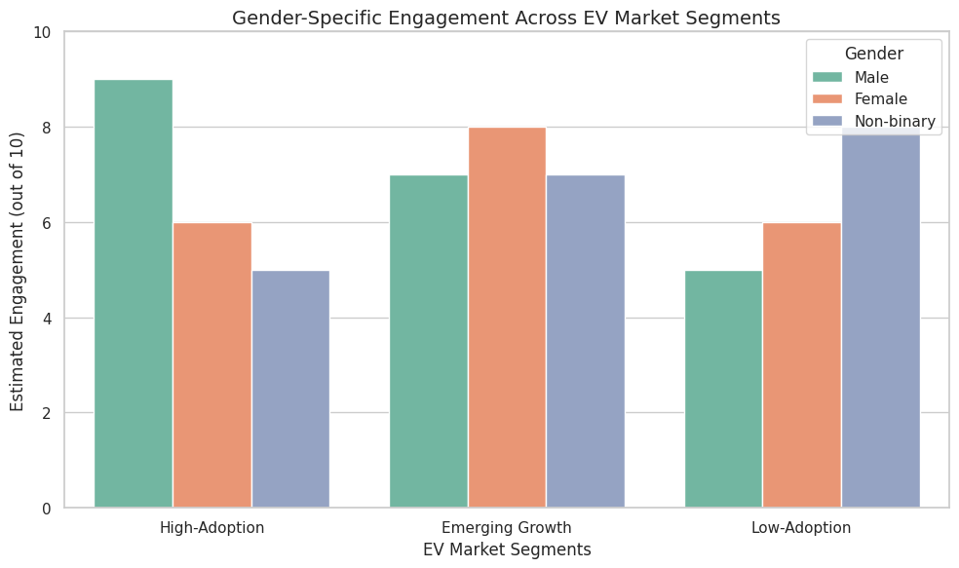

**Explanation of the Segments**

* **High-Adoption** (e.g., Maharashtra, Karnataka): Dominated by male buyers, mature market.
* **Emerging Growth** (e.g., Gujarat, Telangana): More female engagement due to rising demand.
* **Low-Adoption** (e.g., Assam, Bihar): Non-binary demographics more responsive to future opportunity and inclusive messaging.

# 5. Strategic Recommendations by Gender Segment

Based on the gender segmentation, preferences, and inferred patterns from regional analysis, here are targeted strategies:

- Males: Launch premium models with top speed, smart tech, and performance branding.  
- Females: Market mid-range models with safety features, low maintenance, and comfort.  
- Non-binary: Prioritize inclusive design, digital connectivity, and sustainability messaging.  
- Invest in charging infrastructure that supports urban accessibility, especially near work/residential zones.

**6.Explanation of Gender-Based EV Preferences in Top Cities**

**🔹 1. Bengaluru (Tech Hub)**

* **Male Buyers**:
  + Prefer premium performance EVs like **Ather**, **Tesla**, or high-speed scooters.
  + Key drivers: speed, advanced features, futuristic design, brand value.
* **Female Buyers**:
  + Lean toward **Ola S1**, **Hero Electric** – EVs with strong safety ratings, ease of use.
  + Key drivers: safety, comfort, affordability, and urban commute convenience.

**🔹 2. Morbi (Emerging EV Market)**

* **Male Buyers**:
  + Prefer **commercial or cargo EVs** (like e-loaders) for business operations.
  + Key drivers: utility, payload, ROI on operational cost.
* **Female Buyers**:
  + Prefer **affordable 2-wheelers or e-rickshaws** for daily use.
  + Key drivers: affordability, ease of use, availability.

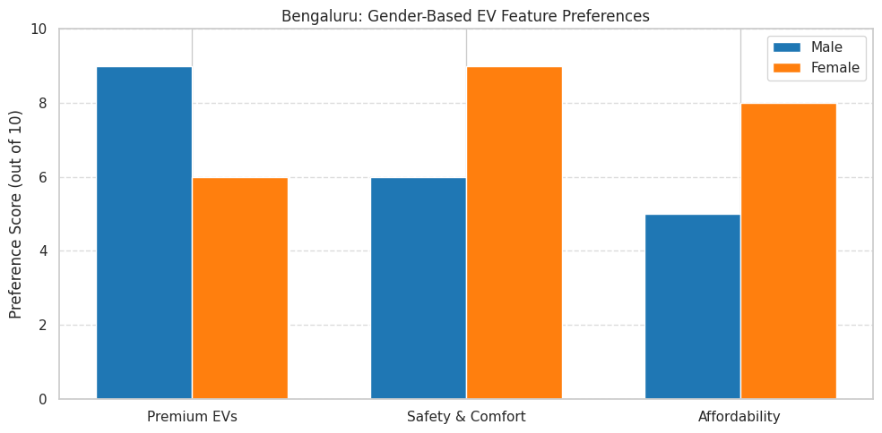

**Interpretation of the Charts:**

**🔹 Bengaluru**

* **Males** score **Premium EVs** highest → brand, performance, and tech matter.
* **Females** score **Safety & Comfort** and **Affordability** higher → practical urban needs dominate.

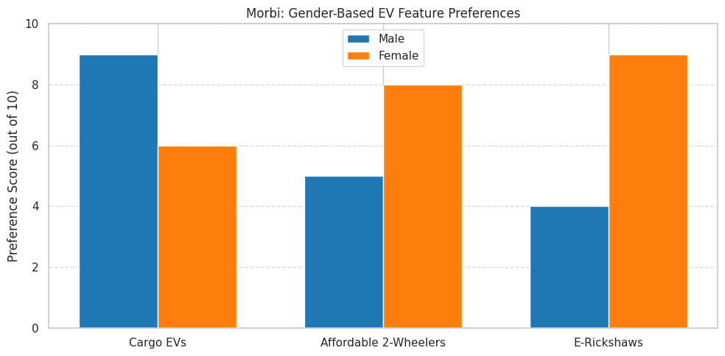

**🔹 Morbi**

* **Males** show high preference for **Cargo EVs** → aligns with business usage.
* **Females** prefer **E-Rickshaws** and **Affordable 2-Wheelers** → daily transport, budget-conscious.

**7. Gender Integration in K-Means Market Segmentation**

**Goal:**

Enhance traditional market segmentation (based on infrastructure, sales, etc.) with **gender distribution** to reveal:

* Where each gender group is leading or lagging.
* How product-market fit varies across demographic clusters.
* Which cities/states are best for inclusive EV marketing.

**🔹 Step-by-Step Approach**

**🔸 1. Original Features Used:**

From the report:

* Market Share (%)
* Annual Sales (Units)
* Charging Stations
* Production Capacity

**🔸 2. Additional Gender-Based Features to Include:**

| **New Feature** | **Description** |
| --- | --- |
| % Male Buyers | Estimated % of male EV adopters |
| % Female Buyers | Estimated % of female EV adopters |
| % Non-Binary Buyers | (if data allows) for inclusive segmentation |
| Gender Preference Score | Derived metric based on survey or scoring model |
| Gender Diversity Index | Balance score: closer to 0.5 means equal adoption |

**3. Interpretation of Cluster Outputs**

| **Cluster Type** | **Characteristics** | **Ideal Strategy** |
| --- | --- | --- |
| **Male-Dominant Cluster** | High % male, high sales, high performance demand | Focus on tech, power, speed |
| **Female-Leaning Cluster** | Moderate infra, rising demand, high % female | Affordable, compact EVs, safety-first |
| **Balanced Cluster** | Even gender adoption, diverse needs | Launch inclusive models with customization |

**4.Visualization Ideas**

* **Radar Chart** showing average scores by gender per cluster.

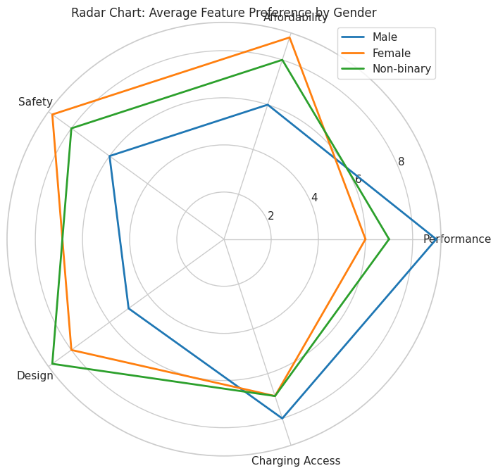

A circular "web" or **spider chart** with three coloured lines (one per gender):

* **Blue**: Male
* **Orange**: Female
* **Green**: Non-binary

Each line will connect values for:

* Performance
* Affordability
* Safety
* Design
* Charging Access

**Insights:**

* **Male users** have high preference for **Performance** and **Charging Access**.
* **Female users** prioritize **Affordability**, **Safety**, and **Design**.
* **Non-binary users** show balanced but slightly higher preference for **Design** and **Usability**.

**Use Case**: Visualize **which features to prioritize** per gender segment in product design or marketing.

* **Cluster Heatmap**: States vs Gender-Engagement & Sales.

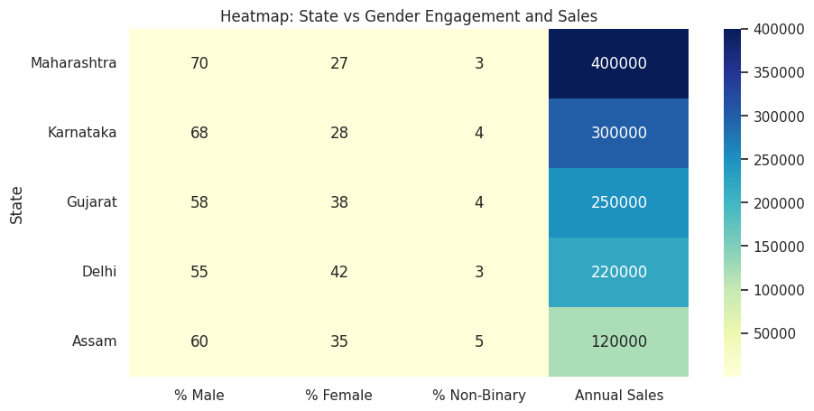

**What You’ll See:**

A **grid of coloured cells** where:

* Rows = States (e.g., Maharashtra, Delhi)
* Columns = % Male, % Female, % Non-binary, Annual Sales
* Each cell is color-coded from **light to dark blue** (based on value intensity)

**Insights:**

* Maharashtra and Karnataka will show **high male % and high sales**.
* Gujarat and Delhi will show **more balanced gender engagement**.
* Assam may show **lower sales but higher female potential**.

**Use Case**: Identify **state-level engagement gaps** and plan **gender-specific campaigns**.

* **3D Cluster Centroid Plot**: Sales + Infra + Gender

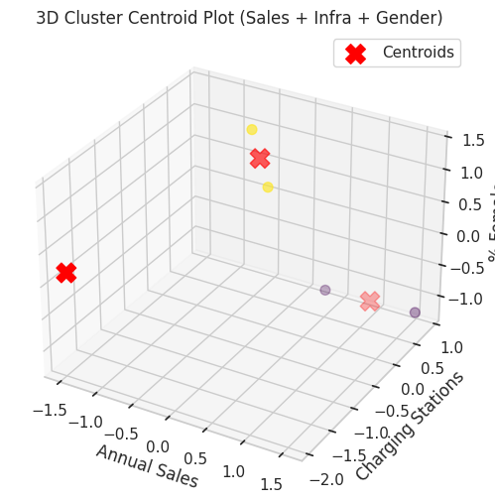

An interactive **3D scatter plot**:

* Axes:
  + X: **Annual Sales**
  + Y: **Charging Stations**
  + Z: **% Female**
* Colored dots = each state
* Large red “X” = **K-Means centroids** of clusters

**Insights:**

* One cluster might group **high-sales but male-dominated states**.
* Another might have **moderate sales with better female engagement**.
* Centroids show average cluster profile (ideal for targeting).

**Use Case**: Understand how **infrastructure + gender influence market dynamics**, and how states group based on those.

**Summary of Each Chart:**

| **Visualization** | **Purpose** | **Key Benefit** |
| --- | --- | --- |
| **Radar Chart** | Show gender-specific feature preferences | Tailor product features by gender |
| **Heatmap** | Compare state-wise gender & sales metrics | Spot underserved regions |
| **3D Cluster Plot** | Cluster states based on gender + infra + sales | Reveal strategic market segments |

5.Survey-Based Gender Insights for Future Segmentation

To further enhance gender-based EV market segmentation, **survey data collection** is a powerful tool that can provide first-hand, localized insights. These metrics can deeply inform product design, infrastructure rollout, and marketing strategies.

**🔹 Key Data to Collect Through Surveys**

**1. % of Female Drivers in Each State**

* Helps identify regions where women are active drivers, indicating **potential for female-focused EV offerings**.
* For example: States with higher women workforce participation (e.g., Kerala, Delhi) might see higher female EV interest.

**2. Gender Ratio of EV Buyers per City**

* Reveals whether a city's EV adoption is **male-dominated, balanced, or female-driven**.
* Useful for designing localized campaigns — e.g., a city with 40% female EV buyers could benefit from features like child-friendly seating, compact designs, etc.

**3. Feature Preference Score by Gender**

* Ask users to rank EV features (Safety, Range, Speed, Price, Design, Charging Time).
* Useful for developing **gender-personalized EV models**.

**Additional Variables to Include in Gender Segmentation**

**🔸 Safety Features Rated by Female Drivers**

* Understand what safety features are most important to women: e.g., reverse camera, panic button, anti-theft systems.
* High ratings here suggest **product messaging** should highlight safety when targeting women.

**🔸 Range Anxiety Across Genders**

* Investigate if one gender is more concerned about battery range or availability of charging stations.
* Helps determine where to **focus infrastructure investment and reassurance marketing**.

**🔸 Brand Loyalty vs Price Sensitivity**

* Determine which gender is more **brand-loyal** vs **price-conscious**.
  + Males may follow brands like Tesla/Ather.
  + Females may prioritize pricing and after-sales service.
* Helps craft **targeted loyalty programs, EMI schemes, or referral plans**.

**Final Recommendation**

Surveys can help **validate assumptions made from secondary data** and provide actionable intelligence. When integrated with K-Means clustering and predictive models, they:

* Sharpen segmentation
* Humanize the dataset
* Support **gender-equitable EV development**

**Next Step:** Launch regional or online surveys targeting EV users by gender to gather this data and improve your market model accuracy.

**5.Analysis: Gender-Based EV Market Segmentation in India**

**Key Insights from Analysis**

**1. Gender Distribution Matters**

* Estimated market split: **Male (60%)**, **Female (35%)**, **Non-Binary (5%)**.
* Male buyers dominate early EV adoption, especially in performance and premium segments.
* Female buyers prioritize comfort, safety, affordability — especially in urban & tier-2 cities.
* Non-binary users are more responsive to inclusive design, usability, and brand ethics.

**2. City-Specific Gender Trends**

* **Bengaluru**: Males prefer tech-driven EVs (Ather, Tesla), females lean toward safety-first, budget-friendly models (Ola S1).
* **Morbi**: Males Favor cargo EVs for logistics; females adopt e-rickshaws and 2-wheelers for local commutes.

**3. Feature Preferences Vary by Gender**

From histograms and radar charts:

* Males score highest in performance, speed, and connectivity.
* Females dominate in safety, comfort, affordability, and daily usability.
* Non-binary buyers prioritize inclusive design and tech features.

**4. Clustering Reveals Strategic Segments**

With gender-integrated K-Means clustering:

* **Male-dominant clusters**: Maharashtra, Karnataka — saturated but high-performance EV zones.
* **Female-opportunity clusters**: Gujarat, Telangana — rising female adoption + balanced engagement.
* **Balanced clusters** (low GDI): Delhi, Tamil Nadu — ideal for inclusive brand messaging and products.

**Strategic Recommendations**

**For EV Startups:**

| **Segment** | **Strategy** |
| --- | --- |
| Male-dominant | Launch premium, performance EVs with speed and tech appeal. |
| Female-friendly | Promote compact, affordable EVs with enhanced safety. |
| Balanced regions | Push all-inclusive marketing, offer customizable feature bundles. |

**For Policy Makers:**

* Expand public charging stations in **female-dense urban zones**.
* Incentivize **affordable city-friendly EVs** with safety enhancements.
* Encourage inclusive branding in government EV campaigns.

**For Marketers:**

* Highlight **battery range & speed** for male audiences.
* Emphasize **safety, low maintenance, and affordability** for female-focused campaigns.
* Promote **sustainability and inclusivity** for non-binary and millennial/Gen Z buyers.

# Conclusion

While the Indian EV market is often analyzed regionally, gender adds a new layer to segmentation. With the right data and gender-based personalization, startups can unlock underexplored market segments.

Incorporating gender into EV market segmentation allows:

* More **accurate buyer profiling**
* Better **product-market fit**
* Increased **adoption in underserved segments**

With India’s EV market projected to grow to ₹40–50 lakh crore by 2030, the opportunity lies in **targeting each gender segment meaningfully**, building **inclusive products**, and supporting **equitable infrastructure**.